

Faculty of engineering - Shoubra Benha University

Research Article / Research Project / Literature Review
in fulfillment of the requirements of
Department | Engineering Mathematics and Physics
Division | -----------
Academic Year | 2020-2021 Preparatory
Course name | Computer
Course code | ECE001

Title(s): -
Build a website on recent computer engineering topics about:
Internet of things.

Name | Edu mail | B. N
علي مسعد احمد علي عسكر | Ali20652@feng.bu.edy.eg | 14

 | Examiners committee | Signature
1 | Dr. Ahmed Bayoumi
2 | Dr. Shady Elmashad
3 | Dr. Abdelhamid Attaby

Part of Code:

<!doctype html>
<html>
<head>
<meta charset="utf-8">
<meta http-equiv="X-UA-Compatible" content="IE=edge">
<meta name="viewport" content="width=device-width, initial-scale=1">
<title>Internet of things</title>
<link href="css/multiColumnTemplate.css" rel="stylesheet" type="text/css">

<style>
table{ width: 100%; border: 2px solid #000;} table th,td{border: 2px solid #000}
</style>
</head>
<body>
<div class="container">
<header>
<nav class="secondary_header" id="menu">
<ul>
<li><font color="000000" > <b> Internet of things </b></font> </li>
<a href="Home.html"><li><font color="FFFFFF"> Home </font> </li></a> <a href="Page (1).html"><li><font color="FFFFFF"> History </font> </li></a>
<a href="Page (2).html"><li><font color="FFFFFF"> Applications </font> </li></a>
<a href="Page (3).html"><li><font color="FFFFFF"> Characteristics </font> </li></a>
<a href="Page (4).html"><li><font color="FFFFFF"> References </font> </li></a>

</ul>
</nav>
</header>
<section>

<article class="left_article">
<h3>Introduction</h3>
<p>The Internet of things (IoT) is a system of interrelated computing devices, mechanical and digital machines provided with unique identifiers (UIDs) and the ability to transfer data over a network without requiring human-to-human or human-to-computer interaction.</p> <p> The definition of the Internet of things has evolved due to the convergence of multiple technologies, real-time analytics, machine learning, commodity sensors, and embedded systems. </p>
<p>Traditional fields of embedded systems, wireless sensor networks, control systems, automation (including home and building automation), and others all contribute to enabling the Internet of things. </p>
<p>In the consumer market, IoT technology is most synonymous with products pertaining to the concept of the "smart home", covering devices and appliances (such as lighting fixtures, thermostats, home security systems and cameras, and other home appliances) that support
one or more common ecosystems, and can be controlled via devices associated with that ecosystem, such as smartphones and smart speakers. </p>
<p>There are a number of serious concerns about dangers in the growth of IoT, especially in the areas of privacy and security, and consequently industry and governmental moves to address these concerns have begun.</p>

</article>
<aside class="right_article"><img src="images/1.jpg" alt="" width="220" height="226" class="placeholder"/> </aside>
</section>

<article class="Bottom_article">

</article>
<div>
<p><br></p>
</div>
</div>
</body>
</html>

Link:

https://muhammed195916.github.io/website/Home.html

Screenshots:

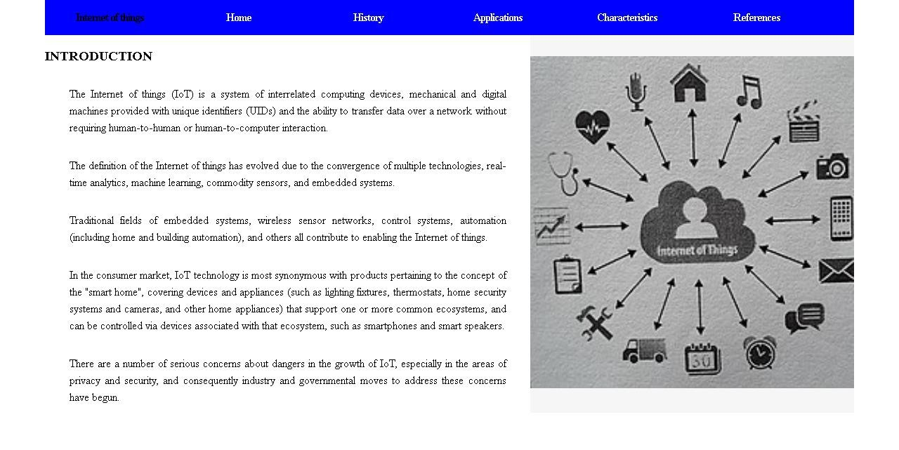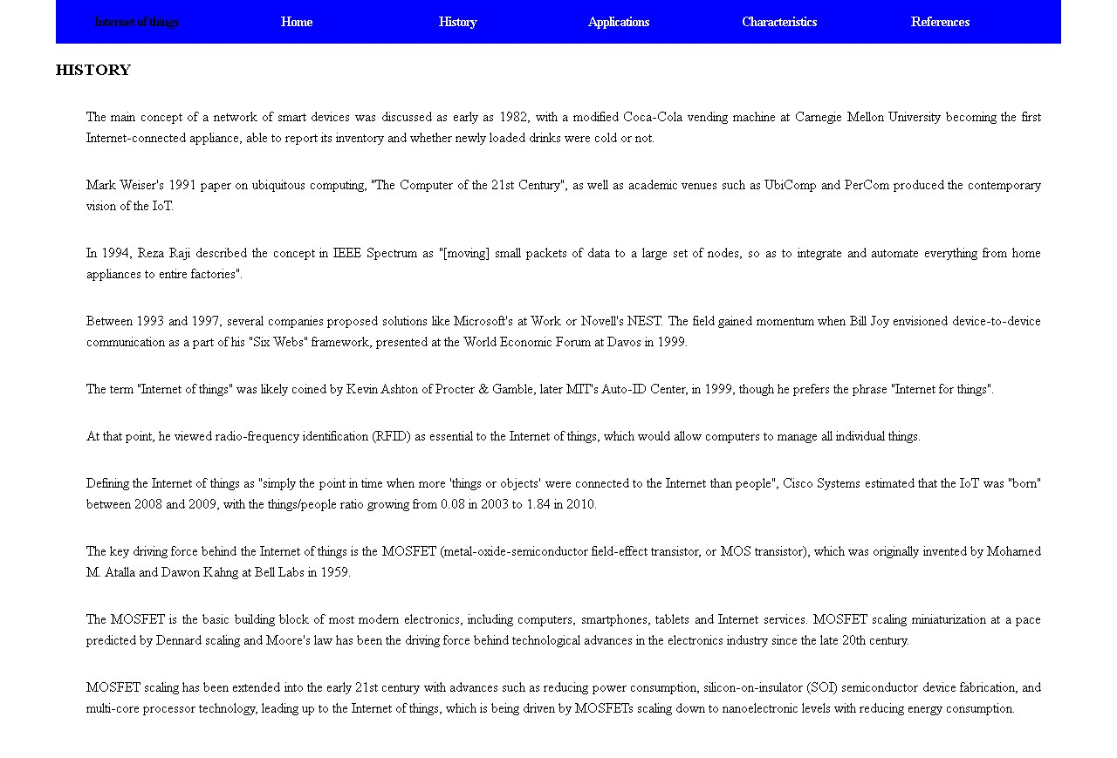

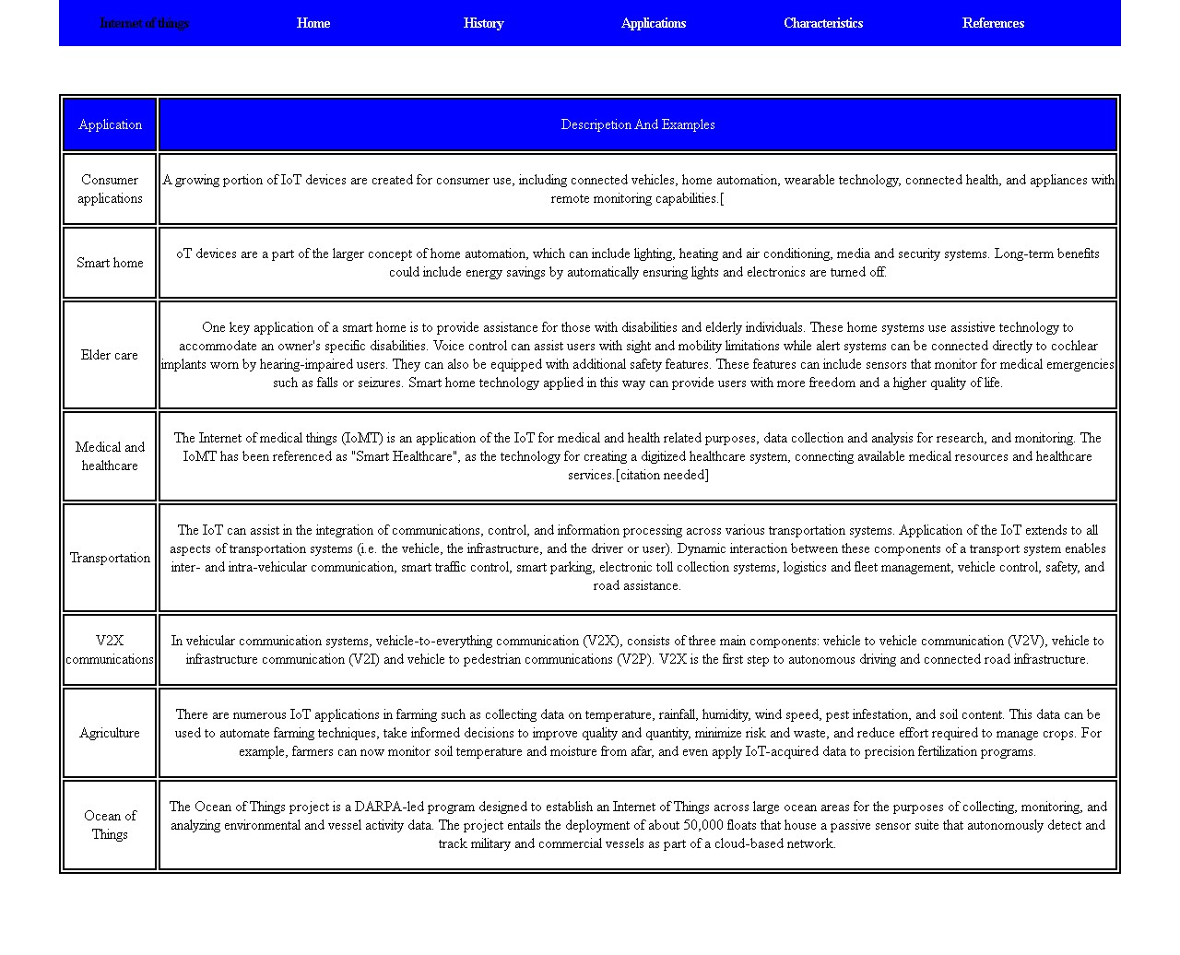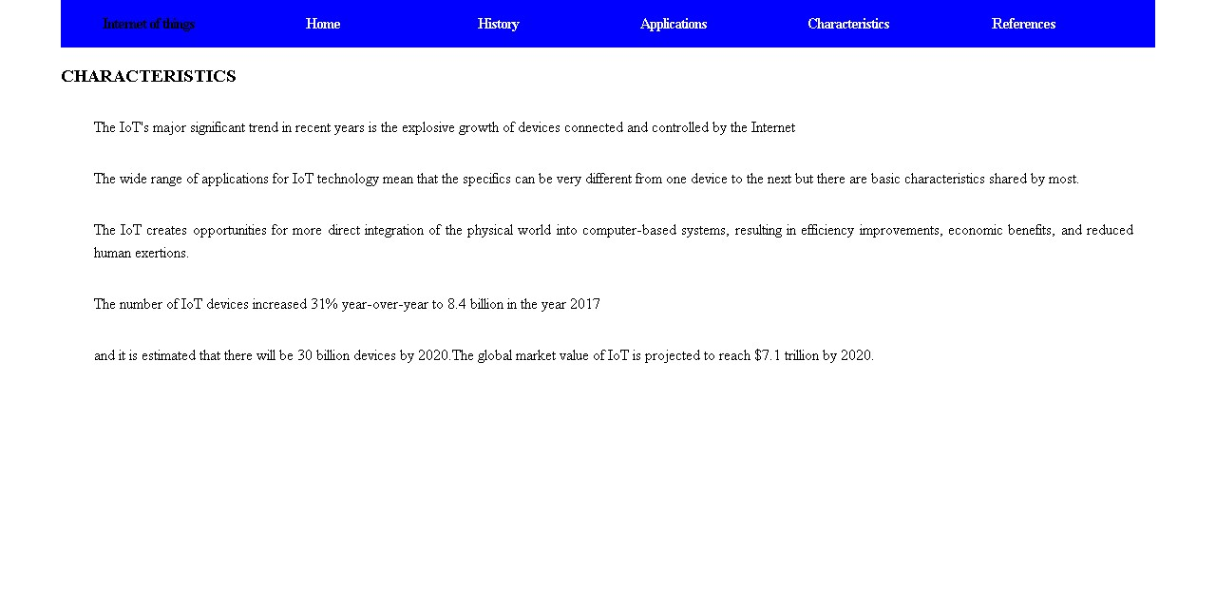

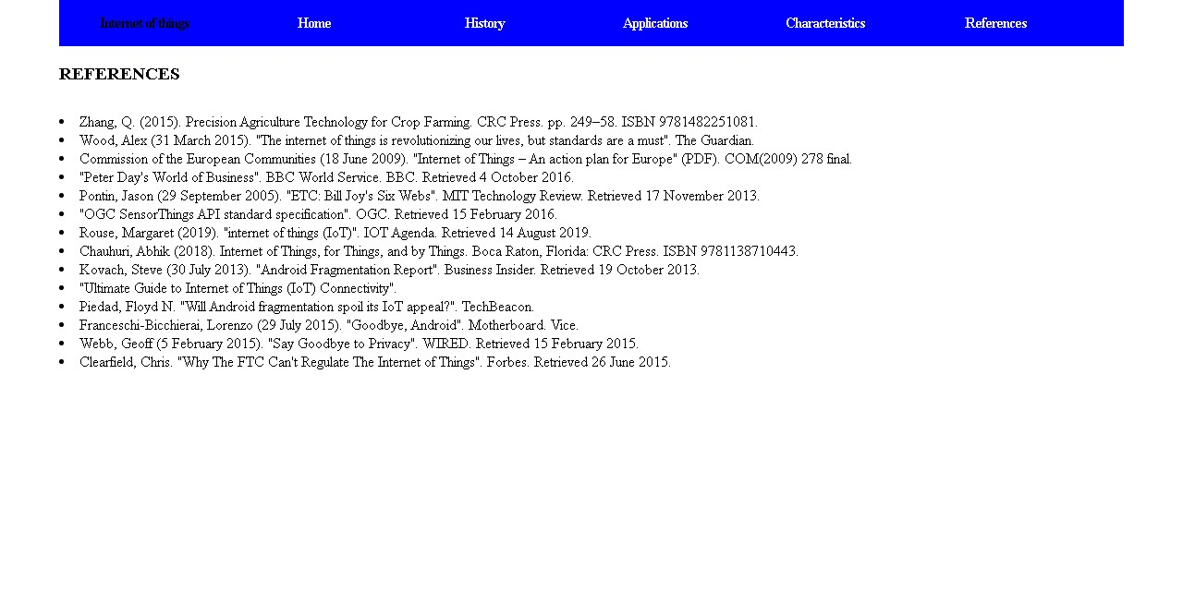

Link:

https://muhammed195916.github.io/website/Home.html

